|  |  |
| --- | --- |
| Canon Selphy CP1300 Photo PrinterMáy In Ảnh Canon Selphy CP1300 (Black)  canon-selphy-cp1300-8 canon-selphy-cp1300-5 canon-selphy-cp1300-6 canon-selphy-cp1300-7 | **Thông tin nổi bật:**  Chế độ Party Shuffle Print, port USB Host  Độ phân giải tối đa 300 dpi  Hỗ trợ AirPrint và Mopria Print Service không dây  Ứng dụng hỗ trợ Apple AirPrint & Canon PRINT  Price: $ 150  **Specifications:**  Canon Selphy CP1300 is a compact photo printer with resolution up to 300 dpi, printing photos from sizes 2.1 x 2.1 inches to 4 x 6 inches. Features an optional battery, capable of printing 54 copies per charge. The device supports AirPrint connection and Canon PRINT Mobile App allowing printing from the phone. Along with that is the 3.2-inch LCD screen design that can be folded up and down, extremely convenient. |

**Overview:**

The portable, compact, convenient Canon Selphy CP1300 photo printer allows users to easily create vivid and sharp photos with a resolution of up to 300 dpi. You can print photos from 2.1 x 2.1 inches to 4 x 6 inches quickly. In addition, the all-new 2 x 6 inch layout feature gives users a variety of options to choose from and create their own print styles.

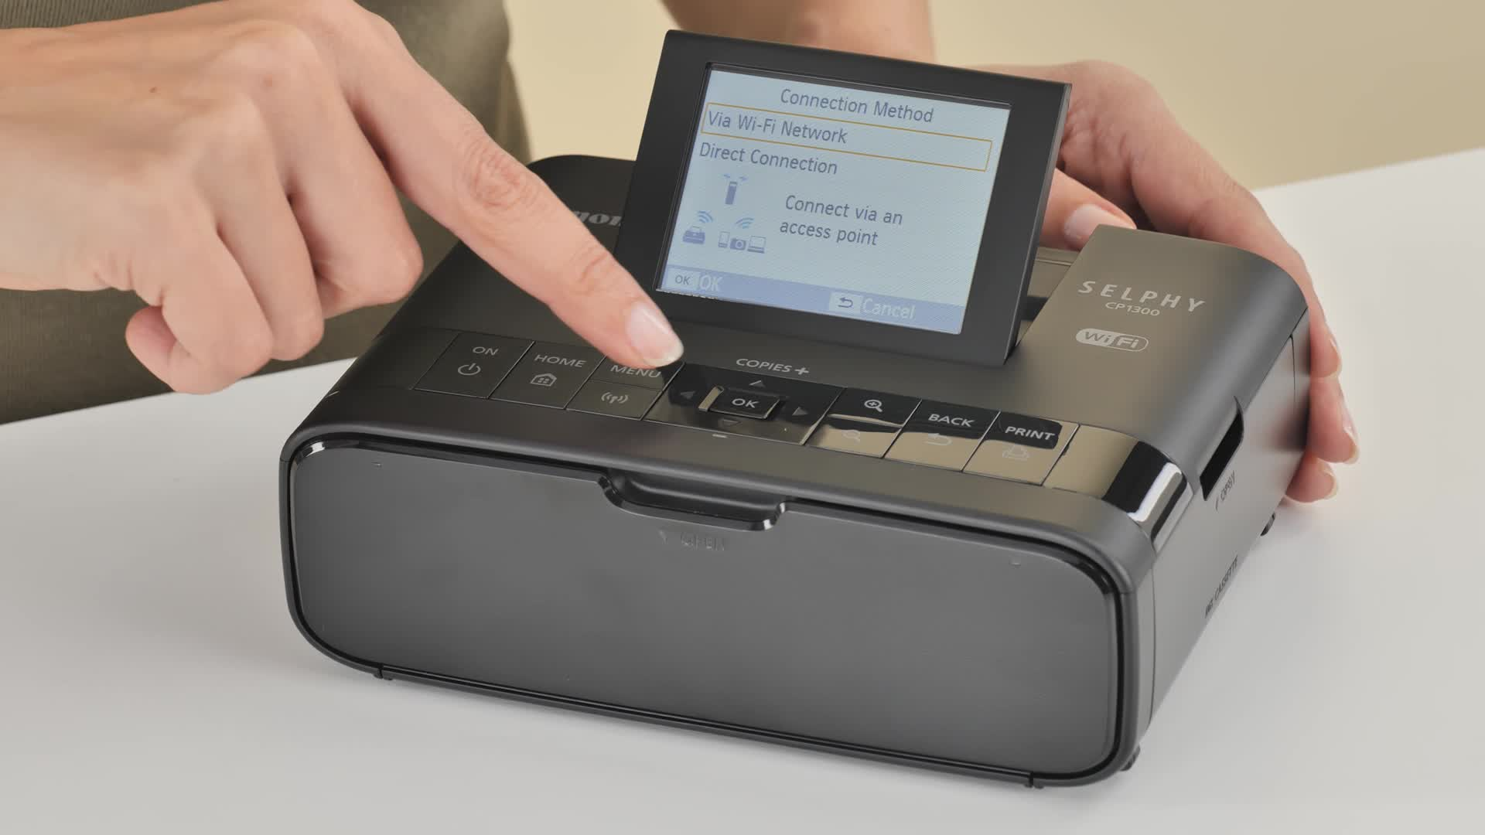

Thanks to the Instant Wireless Printing feature on the Canon Selphy CP1300, users can instantly print photos without using a connection cable. Users can print photos from mobile devices such as phones or tablets via Wifi connection. This saves time and makes it convenient to share memorable memories instantly with friends and family. You can easily search for photos through image collections with the View by date and Multi-playback jump functions.

With wireless connectivity via Wi-Fi, Apple AirPrint, Canon PRINT mobile app and wireless PictBridge, users can easily print photos from mobile devices and computers. The device also integrates the Party Shuffle Print feature, allowing multiple people to connect at the same time to create unique photo collages.

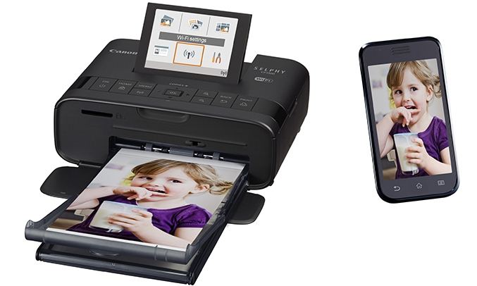

Photo color is durable and long lasting

The photo color quality on this Canon accessory is also extremely durable, thanks to the special protective film on the photos that helps protect the color and preserve it for up to 100 years. In addition to traditional glossy paper, printed photos are made of three other materials: matte finishing material, smooth finishing material, and mesh. Not stopping there, the optional battery can print 54 photos per charge, allowing you to freely experience many different frames.